Online Shopping System: FootFusion

Use-Case Specification: Manage Shopping Cart

Version <1.0>

Revision History
Date | Version | Description | Author
28/11/2024 | <1.0> | Final Draft | Doan Thi Phuong Hong

Table of Contents
1. Use-Case Name 4
1.1 Brief Description 4
1.2 Actor 4
2. Flow of Events 4
2.1 Basic Flow 4
2.2 Alternative Flows 5
3. Special Requirements 5
4. Preconditions 5
5. Postconditions 5
6. Extension Points 5
7. Prototype 6
7.1 Add Order to Shopping Cart 6
7.2 Delete Order to Shopping Cart 9

Use-Case Specification: Manage Shopping Cart

Use-Case Name

Brief Description
This use case enables the FootFusion system to manage the shopping cart, allowing users to add or remove products as they consider their purchasing decisions.

Actor
Users/Buyers

Flow of Events

Basic Flow
Like other use cases, "Manage Shopping Cart" involves two key steps to ensure the system's functionality:
2.1.1. Add Products to Cart:
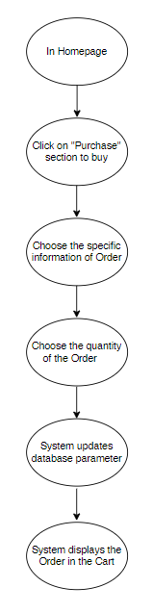
2.1.2. Delete Product in the Cart:
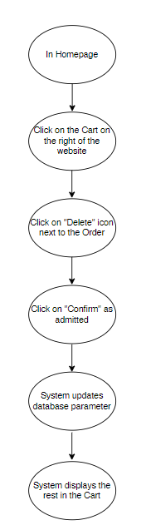

Alternative Flows
There is no alternative flow.

Special Requirements
Users must have an account with valid personal information to access the FootFusion system.

Preconditions
None.

Postconditions
User commands (adding or deleting products) must be executed successfully.

Extension Points
None.

Prototype

Add Order to Shopping Cart
Step 1: On the FootFusion homepage, users can select a product they want to buy.

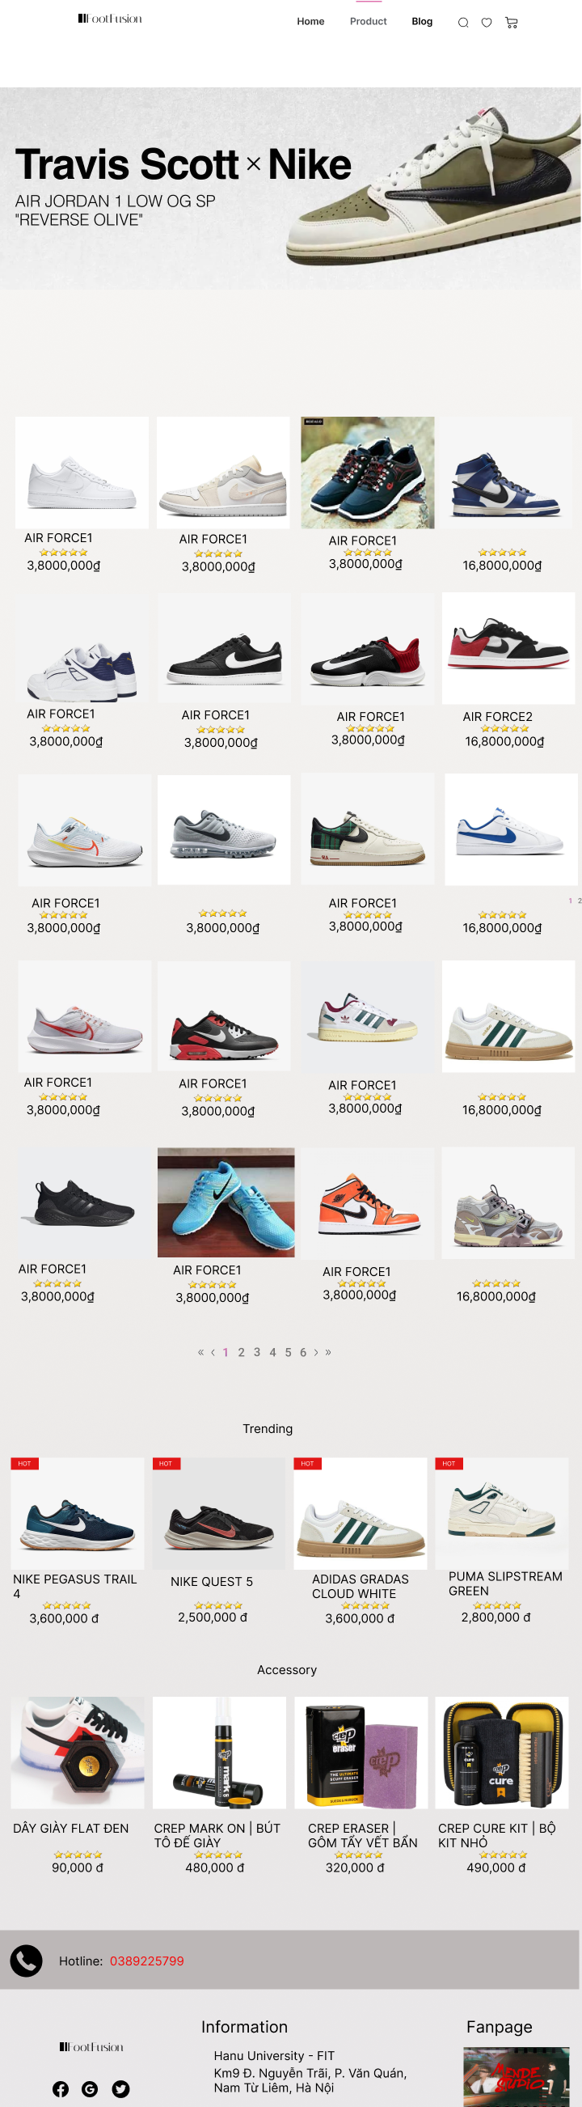
Step 2: After selecting a product, the system displays the product's details.
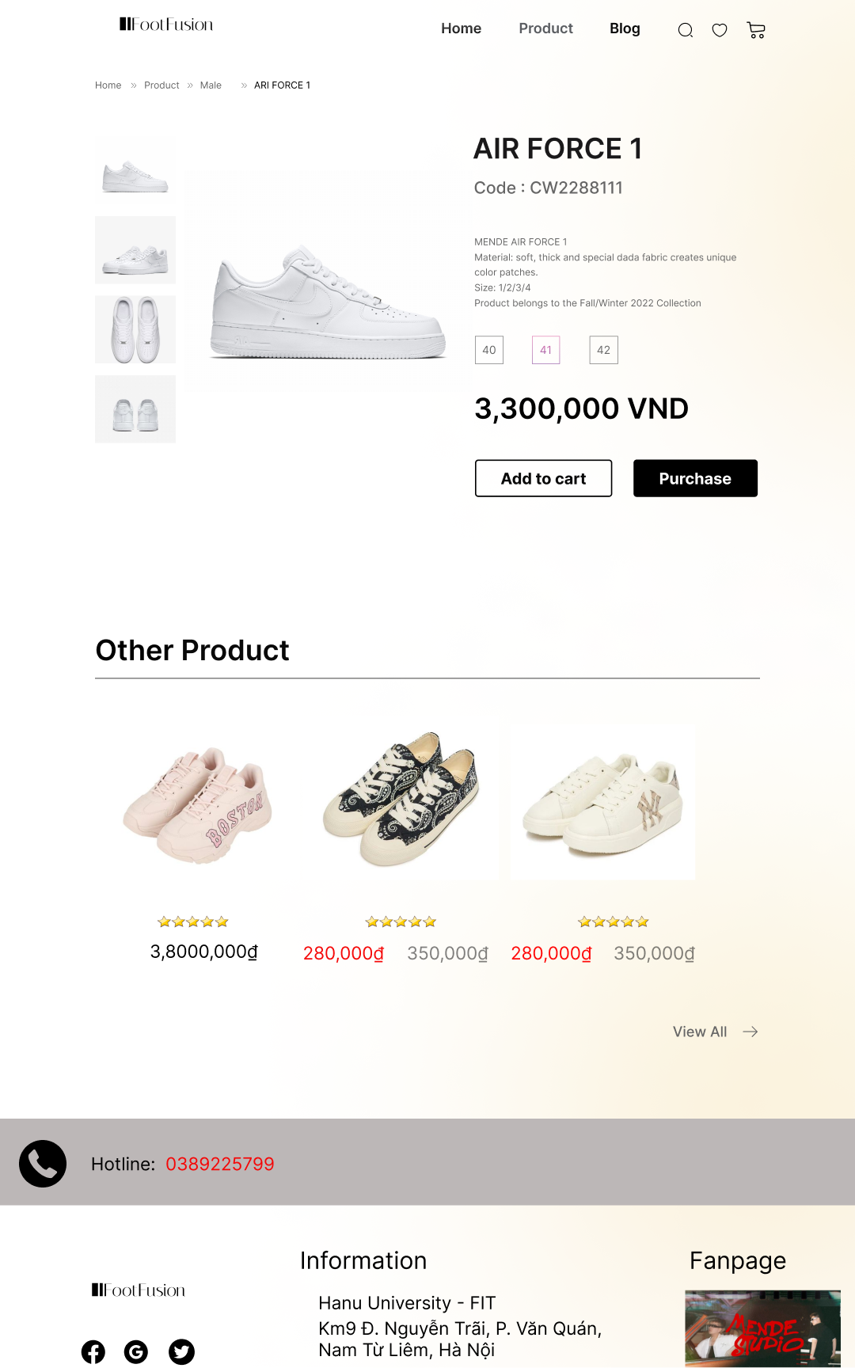
Step 3: After clicking on “Add to cart”, the System will display the screen for users to choose the quantity of the product
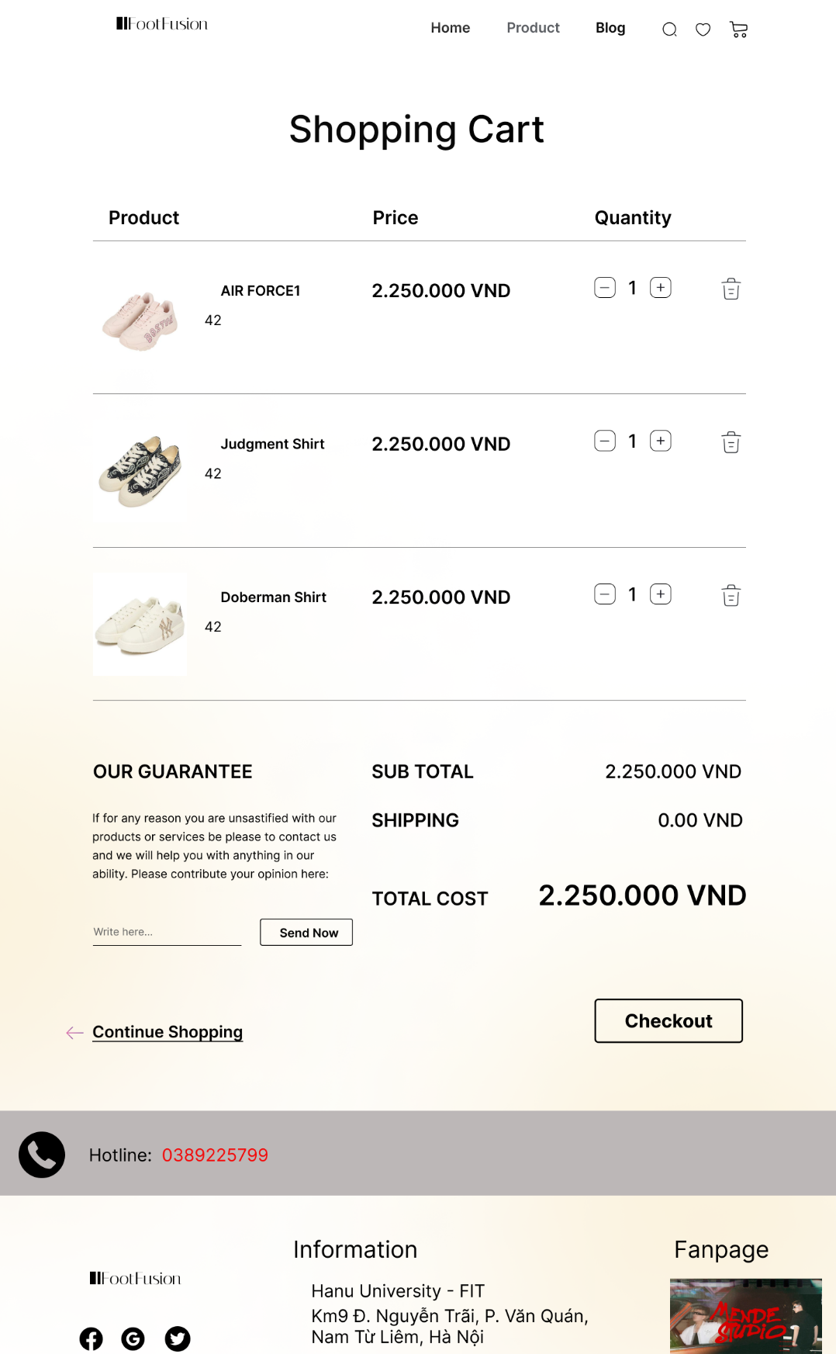

Delete Order to Shopping Cart
Step 1: On the FootFusion homepage, users navigate to the "Cart" section in the right sidebar


Step 2: In the Cart, users click the "Delete" icon next to the product they want to remove.

Step 3: The system displays a success message confirming the deletion and updates the cart to reflect the changes.
